Villa, Joshua Alexander

Liwag, Jon Carlitos

MP 3-Matlab Screenshots

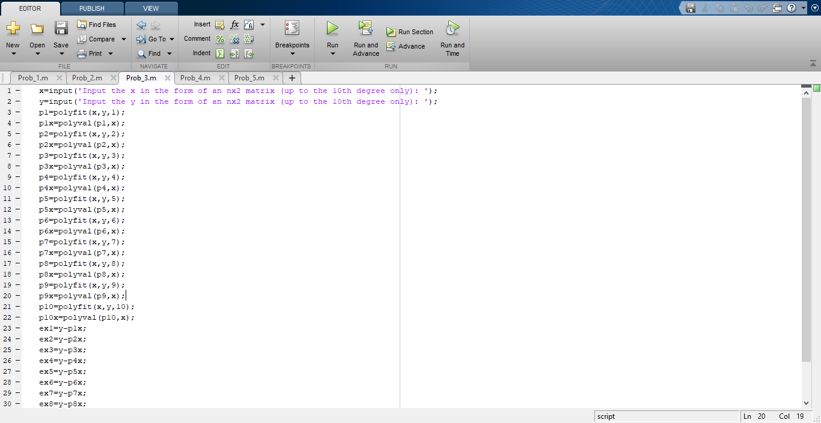

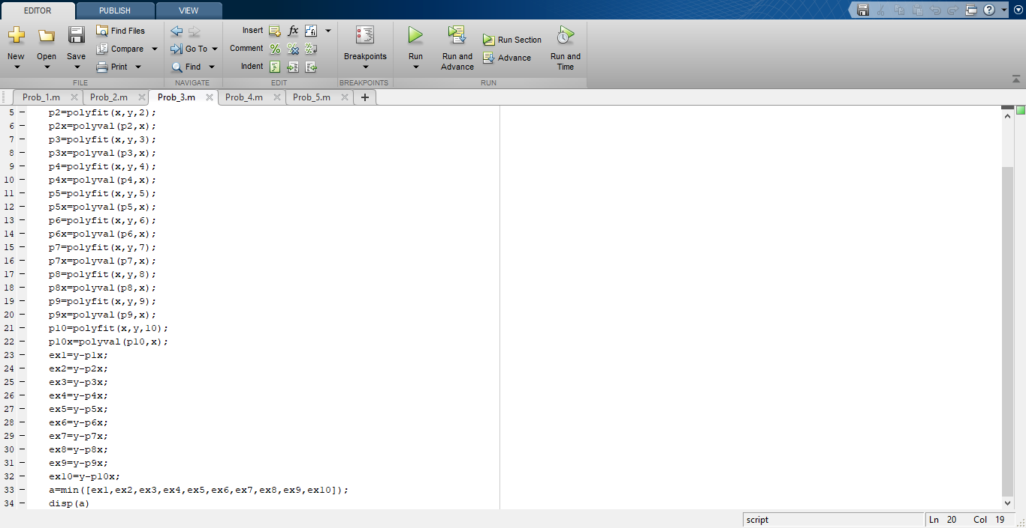

C:\Users\Pink Guy\Documents\ShareX\Screenshots\2019-12\MATLAB_1CFwAjyhnh.png

